

**Midterm Report**

**Web Application Development**

**Project: Chair Shop Website**

1. Basic Information

* Date of Documentation: 10/11/2023
* Class: 21KTPM1
* Team Leader: Đặng Quốc Thái, 21127545
* Team Members:
* Đặng Quốc Thái, 21127545
* Hồng Minh Âu, 18127150
* Website Name: Stelling Chairs
* Design Tools: HTML, CSS
* Development Tools: Node.js
* Framework: Bootstrap
* Repository: GitHub

1. Report
2. Description
3. Overall Description:

Stelling Chairs is a custom e-shop website designed to help customers look for, and search the chairs they find most suitable for their requirements, as well as helping them with the simplest and most effective buying procedures. It also helps the shop administrators add new products, manage existing products, and monitor the website's customers.

1. Demo Screenshot:

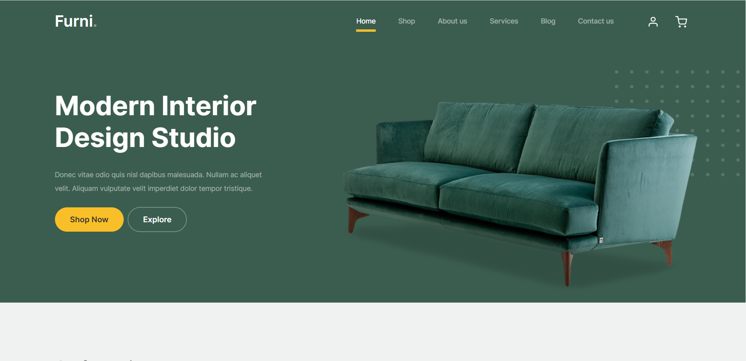





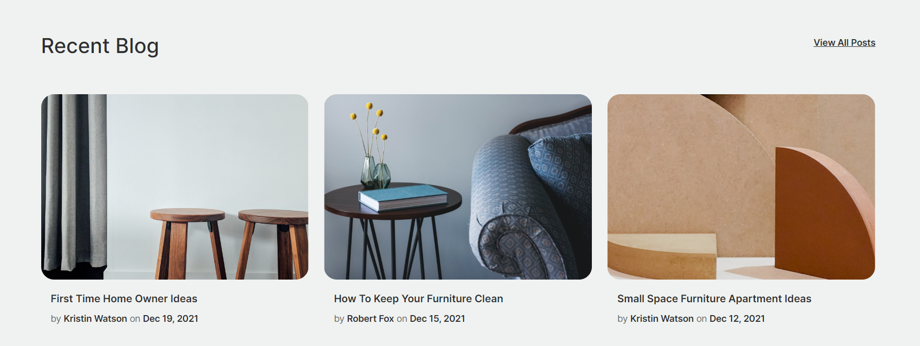



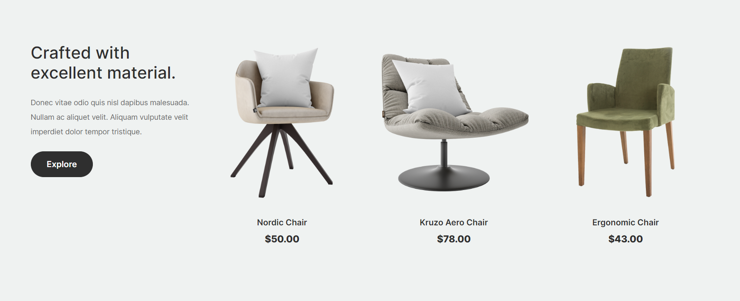



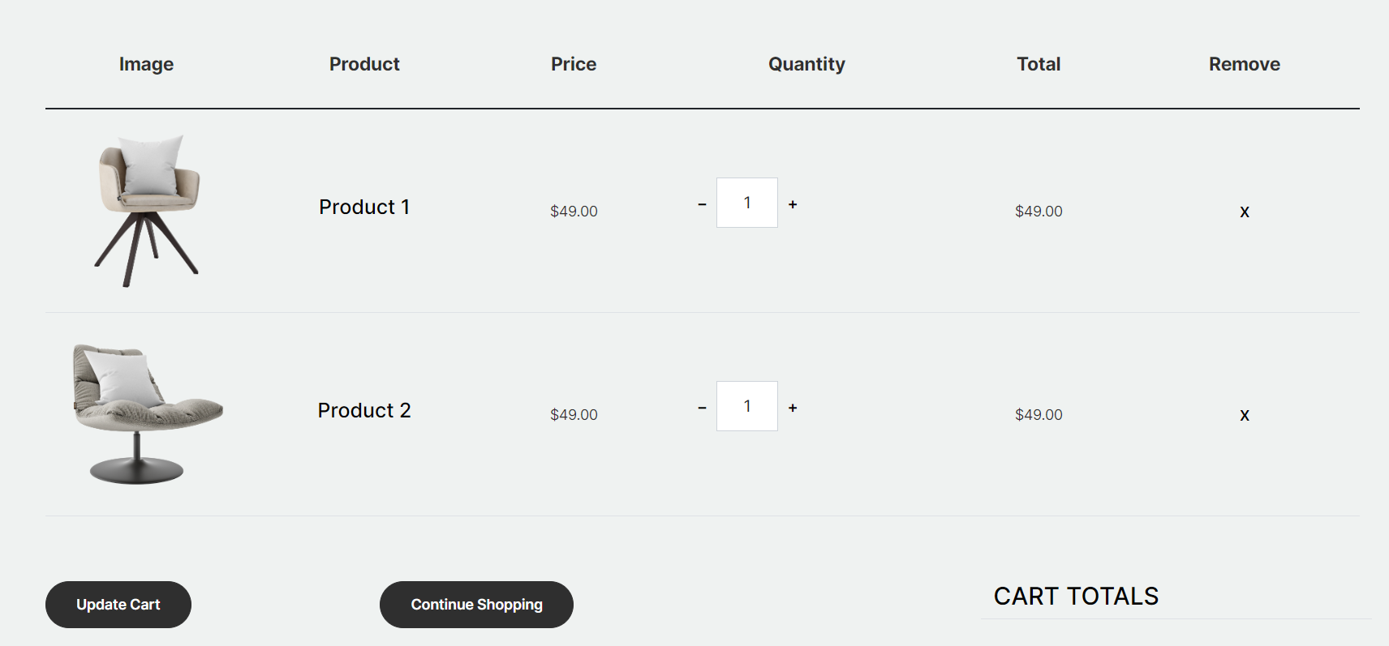



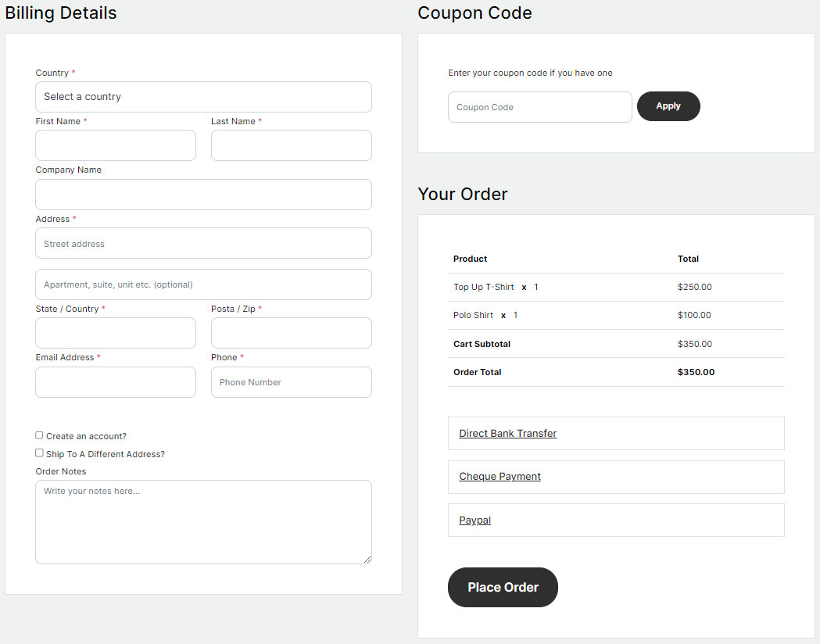

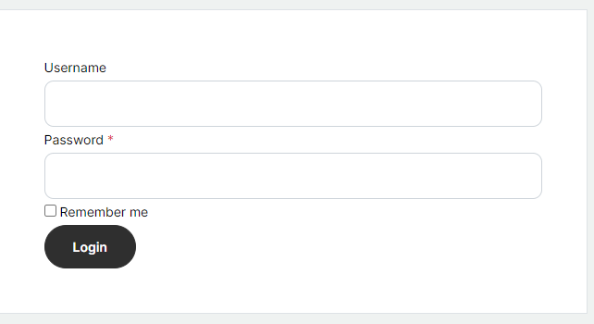

2. Database Schema

